***4.184* SYLLABUS**

**Towards an Understanding of AI in Architectural Design**

*Instructor*:  *Prof* **Mark Goulthorpe** *he, his, him*(Architecture) [mg_decoi@MIT.edu](mailto:mg_decoi@MIT.edu)

*Guests:* Prof Mark Burry, Prof Marc Downie, Dr Jorge Duro-Royo, Kii Kang

*Day/Time*:  Mon 1-4pm   
*Location*: **1-134**

*Credits*: **3-0-9** (3 hours classwork, 6 hours reading/independent homework per week)

*Grading:* per *MIT*/Dept general guidelines, reflecting grasp of issues and aptitude in your response

*Equity:* The course will followMIT policies on gender, racial, sexual equality. Please establish preferred pronouns, and feel free to express any concerns to the Instructor.

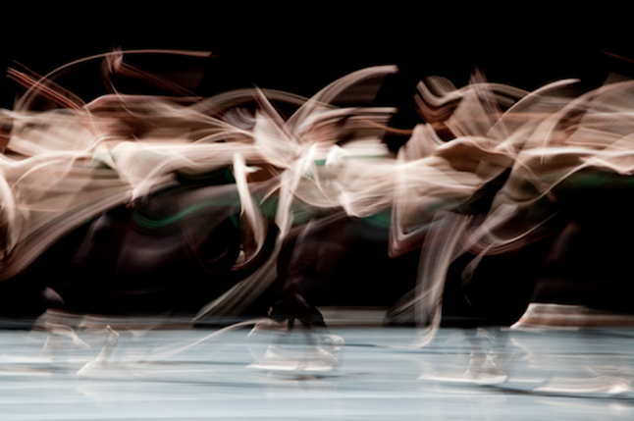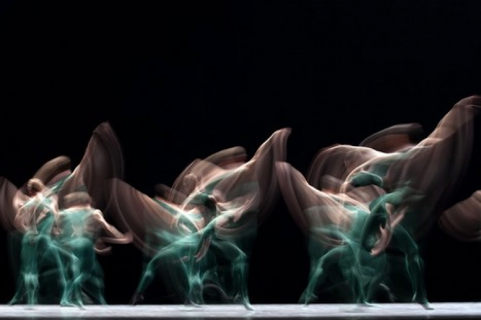

William Forsythe, *Choreographer* ***Frankfurt Ballet***

This part-seminar, part-workshop looks to identifying changing patterns of creativity across the arts under influence of new technical *apparati* (phono, photo, filmic…) looking to trace the emergence of *rule-based generative processes* and their accelerating proclivity via current *computational media.* While there is evidence of parametric praxis as far back as the Roman engineer, *Vitruvius*, and iterative geometric processes implicit in historic Islamic and Oriental art forms, it is in the late 19th century and early 20th century that vivid new modes of auto-poietic praxis take hold, as if aspiring to a far greater degree of machinic salience. The resulting artworks - literary, sonic, kinetic, plastic - quite radical in their disjunctive form, were often scorned as bizarre in their novelty and aspiration. Yet their influence, looking to exceed intuition and direct creative aptitude in favor of symbiotic (human-machine) drives, was formative for modes of avant-garde production early C20th, and extends to ever-more normative generative practices late C20th and early C21st. As *computation* then absorbs all such prior disruptive *apparati*, imbuing them with powerful *generative* potency, so such lineage seems destined to become established, even dominant, in mainstream patterns of production and reception. We will look at a variety of cultural fields, but **architecture** will be the prime focus here, since despite being held to be slow to adapt to technical change, one finds pioneering works (often vaunted in the contemporary field) that offer plastic counterpoint to more agile literary or kinetic art forms...

This seminar component encourages *looking back* to the origins of any given field (their *enabling constraints*) as much as identifying salient pioneers of rule-based generative methods *(auto-poiesis)*. The intention is to allow recognition that the *creative method is vital to the final artwork*(how working in a new manner is vital to innovation)*.*But pivoting to the workshop component, this prompts a*looking forwards* in students attempting precisely-indeterminate formative-isms, deploying such insights into creative experimentation via a now-digital imagination (whether using a computer or not). The lineage of experimental creativity intends to offer framing of new aptitude and imagination, allowing us to theorize changing artistic motivations under influence of emerging technologies. At root is the idea that creativity or design is not static but shifts through history under influence of the various technical systems that society adopts, none more powerful than the current shift to digital media. Current AI likely offers profound changes in both cultural production *and* reception; our gaining insight into prior *autopoietic* habitudes offers a key to emerging creative drives, likely requiring technical acuity and aesthetic openness.

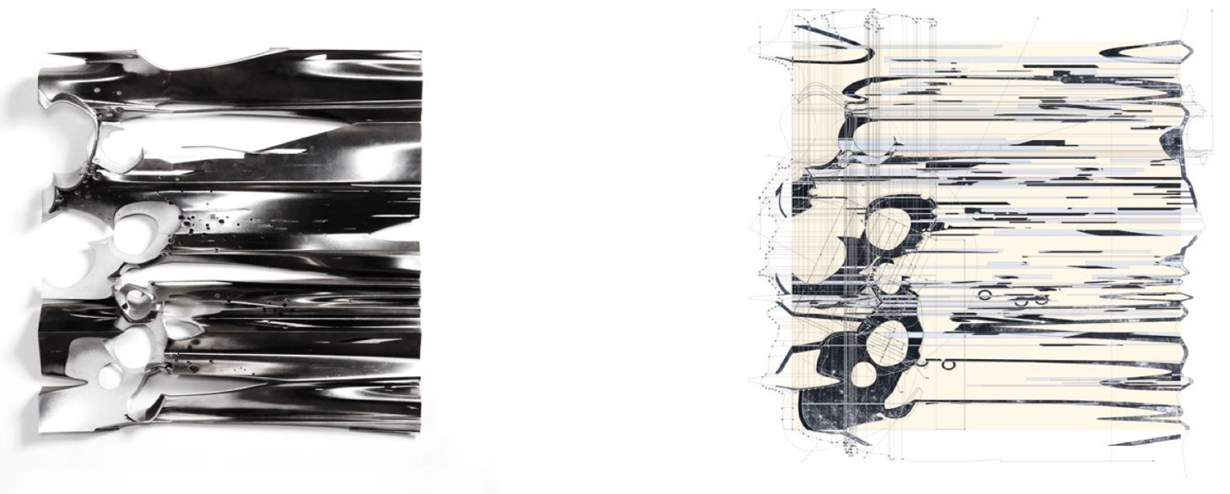**Case Studies**

***Drawdles***by *Morphosis Architects*

*The seminar/workshop is for those interested in new patterns of creativity engendered by changes in technical apparati, evidently none more salient than the on-going shift to digital media and AI. It will ask for analytical and creative responses to material that we identify, frame and un-pack, and collaborative work will be encouraged. The instructor is a design architect, with curiosity as to digital media, but (more so) with broad cultural and technical appetite; the various guests are engaged in different ways in generative architectural drives, typically with particular computational skill. So all are welcome, and computational skill is not a requirement but can certainly be put into play! We will aim to generate as a means to theorize what we understand by the potential for AI in Architectural Design.*

*Historic Rule-Based Generative Artists* in the **Literary, Sonic, Kinetic, Visual** Arts

*Creative Figures we will reference and draw from:*

**Raymond Roussel** writer/playwright *Impressions of Africa, New Impressions of Africa, How I Wrote…*

**Antoni Gaudi** architect *La Sagrada Familia, Guell Chapel, Hanging Chain…*

**Kurt Schwitters** artist/sculptor *Merzbau 1, 2, 3…*

**James Joyce**  writer *Finnegans Wake…*

**Bill Forsythe**  ballet choreographer Improvization Technologies, *Synchronous Objects…*

**Thom Mayne**  architect *Drawdles, DrawdRules, Shanghai Campus…*

**Paul Steenhuisen** composer *Wonder, HypoSurface…*

**Marc Downie**  visual artist/film maker *Saccades, Drawn Together…*

**Readings**

*Some texts we will focus on closely, others are offered to offer background theoretical: context:*

**Vitruvius** *De Architectura*

**Bernard Cache** *De Architectura*: On the Table of Contents of the Ten Books of Architecture, 2009

The Tower of the Winds of Andronikos of Kyrros, 2009

**Andre Breton** *Surrealist Manifesto*, 1924

**Gaston Bachelard** *The Poetics of Space*, 1958

**Gregory Ulmer** *Heuretics,**The Logic of Invention*, 1994

**Martin Heidegger** essay ‘*The Question Concerning Technology’*, 1954

**Gianni Vattimo** *The Transparent Society*, 1989 ch 4,5,6

**Walter Benjamin** essay ‘*Art in the Age of Mechanical Reproduction’*, 1936

**Marshall McLuhan** *Understanding Media, the Extensions of Man*, 1964

**Jacques Lacan** *Seminar 23*, 1976

**Luce Irigaray** essays *Plato’s Hystera* and *The Mechanics of Fluids*, 1987

**Betti Marenko** essays, *UnDesign. The Un-designability of the Virtual*, 2015

**Speakers**

The 4 guest architects (Burry, Downie, Kang, Duro-Royo) will offer independent frameworks for (their) understanding and experience of AI for DESIGN, and likely frame the work of others that they find prescient. The goal is to allow the class to absorb a range of approaches to the potentials for rule-based generative DESIGN in devising the complex material/spatial assemblies that architecture typifies.

**CourseWork**

Students will be asked to produce three pieces of work:

* elucidate 1 generative aspect of ancient design praxis from Vitruvius’ *10 Books*
* attempt a “drawdle” that deploys material/formal qualities from (your) personal predisposition
* devise an auto-poietic architectural methodology that offers potential for co-design, self-design, and/or AI design: these imply that a user interface of some sort?

Of these works, one must be *analytical* (hermeneutic), one *inventive* (heuretic), one *collaborative* (analytical or inventive): you can choose which approach is appropriate to each. You are encouraged to seek media that are appropriate to the production & reception of your project, as did the creative practitioners and theorists under study. *Risk* is vital to conveying the production and reception of such pioneering works: *in their moment such works were often seen as aberrant and a-cultural!*

**CATTt** *(Contrast, Analogy, Target, Theory, Tale)*

A CATTt analytical armature (Greg Ulmer) will be introduced (a form of inventive *theo-prax-esis* as counterpoint to an ossified analytical *thesis*). This may equally be turned into a *generative* device (a bachelor machine), intending to foment lucid but surprising material: effectively, this is the generative device used by most of the artists we’re looking at – a highly structured discipline-specific armature that provides *impetus* (to/from) and *justification* (examples/theory) that structures their vivid artistic output.

**Pedagogical goals**

*1 Research (analytical)*

The initial period of research into rule-based creative exemplars and texts on cultural production/innovation aims to understand the long history of computational (rule-based generative) methods; (*eg* Vitruvius, Andronicus, Durer as framed theoretically by Bernard Cache, Mark Burry, etc)

*2 Engagement (collective)*

The examples of C19-C21 rule-based generative artists (*eg* Raymond Roussel, Bill Forsythe, Antoni Gaudi, Thom Mayne…) offer patterns of creativity that once unraveled can be *emulated*; while the theorists and speakers offer framing of the originality of their processes and the aesthetics of the resulting artworks. This intends to allow seemingly obscure creative praxis to be absorbed, engaged, extended...

*[Perhaps use the CATTt framework offered by Greg Ulmer to try to articulate what each artist was attempting: Contrast, Analogy, Target, Theory, tale? This analytical armature he points out may be turned into a generative device, forcing lucid but surprising artwork. Use of such an armature will force you to provide an impetus (to/from) and a justification (examples/theory) to give form to your own artwork.]*

*3 Invention*

The goal is to create or extend a new auto-poietic process that derives from ANY of those witnessed by the group (or others), and that makes use of any of the theorists introduced. By all means use one of your own projects as a vehicle for this, or invent one – it can be any artform (literary, sonic, kinetic, visual, plastic…) As we navigate the emergence of novel generative processes across the arts, doubtless impelled by the remarkable computational prowess now emerging, the basic question is whether *invention* can be seen to have a structured pattern, and is then able to be *taught* and *learned*; this is to challenge the assumption that such pioneering rule-based generative artists are elusive creative geniuses, and to instead hold them up as *educators of method* (that suits a computational epoch): *harbingers of intelligent artifice*.

**Calendar**

This can be loosely adhered to – we will meander as needed per topics of interest to the class.

*Sept 9* Auto-Poiesis (Rule-Based Generative) Introduction

*Example:* Bill Forsythe +Frankfurt Ballet

*Work:* read Cache on Vitruvius, select a parametric issue in the 10 Books

*Sept 16* *Theory:* Bernard Cache *Vitruvius* essay and *Tower of the Winds* lecture

*Example:* Stealth*House + DECOi*

*Work:* elucidate a paramorph (schema) drawn from *Vitruvius*

*Sept 23 Theory:* Creative Praxis in Gaudi’s *Sagrada Familia* + *Guell Chapel* Mark Burry

***Pin-up****:* Students’ *Vitruvius Schemas* – outline principles (w/Kang, Duro-Royo)

*Sept 30 Theory:* Marc Downie: *Thoughts on AI for Architectural Design (KEN)*

***Pin-up****:* Student *Vitruvius Schemas* – final project

*Oct 7 Theory:* MG onThom Mayne’s *Drawdles + D*ECOi’s *HypoSurface (Steenhuisen/Downie)*

*Work: attempt a Drawdle or its conceptual equivalent*

*Oct 14* INDIGENOUS PEOPLES’ DAY HOLIDAY *(no class)*

*Oct 15 Student Holiday (no class)*

*Oct 22 Theory:* Jorge Duro-Royo + Kii Kang: Thoughts on AI for Design *(KEN)*

***Pin-up****: students present Drawdles or their conceptual equivalent*

*Oct 29* *Theory:* Ulmer’s CATTt armature as both an analytical and generative system

*Presentation:* students identify an area of architectural focus for their final AI project – it can be a building element, or a system, or an envelope or a total architecture. Class discussion trying to identify salient aspects of making this fully computable.

*Nov 11* VETERANS’ DAY HOLIDAY (No Class)

*Nov 12* I think class will be moved to Tuesday, so barring clashes we can meet and look at DECOi’s attempt to make total buildings computable.

*Nov 18 TBD*

*Nov 25 Pin-Up:* Students’ **CATTt and AI-enabling Architecture**

*Dec 2 TBD*

*Dec 9 Final Review*: Students’ **CATTt and AI-enabling Architecture**

*(w/ Burry/Downie/Kang/Duro-Royo)*

*Dec 11 MIT* LAST DAY OF CLASSES