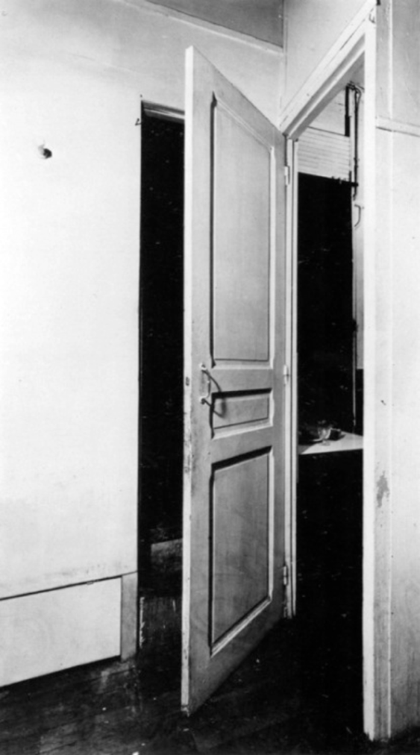

COURSE DESCRIPTION
Architecture & Thresholds offers the opportunity to explore the architectural design potential of entries and exits—of liminal and in between spaces. As illustrated in Marcel Duchamp’s door 11 rue Larrey from 1927, every threshold is on the verge of--it is both an opening to and closure of. Each threshold holds the space between two conditions.

The approach of the class is informed by a range of iterative and rule-based practices in literature, mathematics, art, music and architecture. In art and music, instructional compositions informed by repetition, variation, and singularity (uniqueness) from the chance compositions of John Cage to the wall drawings of Sol Le Witt to the painting and constructions of the architecture studio Pezo von Ellrichshausen. Other models the exploration in Exercises in Style by Raymond Queneau and 99 Variations on a Proof by Philip Ording, two works that begin with a simple premise that is reinvented one hundredfold by a new set of principles, techniques, contexts, and histories.

Following the model of the OuLiPo group, who’s members applied constraints and mathematical rules to conceive of and structure narratives, students will apply the logic and rules of architectural precedents of their choice to produce a series of variations. Students first select a building threshold from a project that they have previously designed as the foundation for the new threshold variations. The threshold variations will be a detailed study and analysis of select architectural precedents. For the final project, students analyze their threshold variations in a final threshold redesign and physical model at full or half scale. Architecture & Thresholds explores the refinement of architectural design concepts through iterative studies, architectural detailing and construction mock-ups.

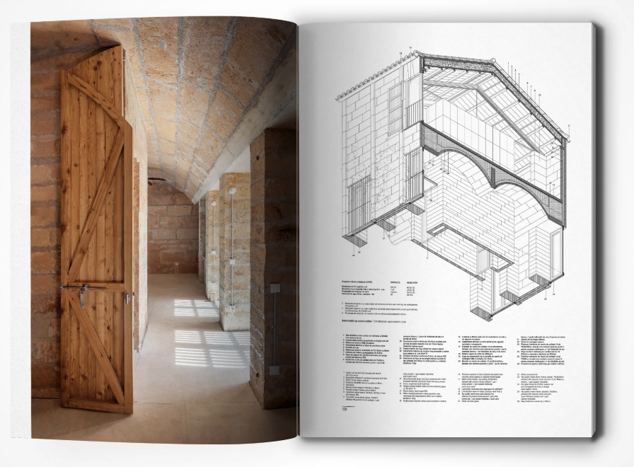

Students are encouraged to choose architectural precedents that continue or challenge the logic of their work. The architectural precedents will be drawn from editions of GA Detail, Global Architecture, El Croquis, and when possible, detailed vernacular and traditional examples (African, Islamic, Japanese, and European). Since the threshold is from a design that each student gave much consideration previously, the final speculation on the threshold design hints toward alternative design approaches and potentials in building design that students can carry forward.

CLASS FORMAT
- Students select a building threshold from a project that they previously designed.
- This threshold will be the foundation for a series of new threshold variations.
- The series of threshold variations will be explored and represented in five threshold detail assignments.
- Each of the first four assignments are split between two classes. In the first class a precedent and tectonic is selected, and in the second class, the revised threshold detail assignment is presented.
- The deliverable for each of the first four assignments is a plan oblique and a section oblique that details and represents the interior and exterior facades.
- The fifth and final assignment also includes a physical model and is explored over several classes and presented as the final project.

LEARNING OBJECTIVES
- Study and interpret the design and details of 4 architectural precedents
- Apply an understanding of each of four architectural precedents to another building threshold.
- Analyze the structure, composition, logic and materiality of four architectural precedents.
- Study, document, and interpret the logic and rules of the precedent.
- Evaluate your original design through the analyses of the concepts and principles of the four architectural precedents.
- Interpret your analyses to design a fifth new threshold.
- Create a new threshold prototype for the original building design that synthesizes and applies knowledge gained from the precedent analyses and rule-based studies.

REQUIREMENTS
- Attend weekly sessions.
- Complete recommended readings and post commentary (the Sunday before class).
- Contribute to the collective discussion in the classroom.
- Complete all detail assignments in time for class presentations and discussions.
- Produce a final analytical threshold and detailed physical mock-up.

GRADES
- Readings and posting in the class forum (15%)
- Contribution to class discussions (15%)
- Assignments #1-4 (50%)
- Assignment #5 (20%)

BIBLIOGRAPY
- Assigned readings will be posted on Canvas over the course.
- Library reserves and digital links of required readings and precedents will be provided when necessary.

BIBLIOGRAPY - PUBLICATIONS (on thresholds, passages, openings, doors)
- Andrews, Stuart and Matthew Wagner, The Dramaturgy of the Door
- (Routledge, 2020).
- Bachelard, Gaston, The Poetics of Space (Beacon Press, 1994, (c1964)).

BIBLIOGRAPY - PUBLICATIONS (on iteration, serial and rule-based practices)
- Mardones Hiche, Patricio, La Poetica Del Quadrato/Quadratic Poetics, Domus, 2011-05 (947), p.34-39
- Mathews, Harry and Alastair Brotchie, Oulipo Compendium (Atlas Press, 2005, (c1998)).
- Ording, Philip, 99 Variations on a Proof, (Princeton Architectural Press, 2011).
- Piekut, Benjamin, Chance and Certainty: John Cage's Politics of Nature, Cultural Critique, 2013-03, Vol.84 (84), p.134-163.
- Queneau, Raymond, Exercises in Style (New Directions, 2012, (c1947)).
- Singer, Sussana, Sol LeWitt Wall Drawings, 1984-1992 (Kunsthalle Bern, 1992).
- Singer, Sussana, Sol LeWitt Wall Drawings, 1968-1984 (Stedelijk Museum, 1984).
- Skurvida, Sandra, John Cage Composing, Computing, and Curating (Routledge, 2025)

BIBLIOGRAPY - PUBLICATIONS (on Details)
- Allen, Edward and Patrick Rand, Architectural Detailing: Function, Constructibility, Aesthetics (Wiley, 2016, c1931).
- Bizley, Graham, Architecture in Detail II (Elsevier, 2010).
- Cremers, Jan, Ed., Building Openings Construction Manual: Windows, Vents Exterior Doors (Edition Detail, 2016).
- Dickinson, Duo, Expressive Details: Materials, Selection, Use (McGraw-Hill, 1997).
- Diderot, Denis, The Architectural Plates from “Encyclopédie” (Dover, 1995).
- Emmitt, Stephen, John Olie and Peter Schmid, Principles of Architectural Detailing (Blackwell Pub, 2004).
- Ford, Edward R., Five Houses, Ten Details (Princeton Architectural Press, 2009).
- Ford, Edward R., The Details of Modern Architecture (MIT Press, 1996, c 1990).
- Ford, Edward R., The Architectural Detail (Princeton Architectural Press, 2011).
- Heschong, Lisa, Visual Delight in Architecture: Daylight, Vision, and View (Routledge, 2021).
- Herzog, Thomas, Roland Krippner and Werner Lang, Fassaden Atlas, (Birkhäuser, 2013)
- Killroy, Christine, Details in Contemporary Architecture (Princeton Architectural Press, 2007).
- Knobloch, Philip G., Architectural Details from the Early Twentieth Century (American Institute of Architects Press, 1991, c1931).
- Gatz Konrad, Modern Architectural Detailing (Reinhold Pub. Corp., 1963- (c1961)).
- Kumpusch, Christoph, Detail Kultur: If Buildings Had DNA: Case Studies of Mutations (AADCU Program, 2016).
- Melet, .Ed, The Architectural Detail: Dutch Architects Visualise Their Concepts (Nai Publishers, 2002).
- Radford, William, Old house Measured and Scaled Detail Drawings for Builders and Carpenters (Dover Books, 1983).
- Selected Architectural Details: the Pencil Points/Progressive Architecture Series (Reinhold, 1944)).
- Tutton, Michael and James Campbell, Eds., Doors: History, Repair and Conservation (Routledge, 2020).

BIBLIOGRAPY - PERIODICALS (Detail Precedents)
- Detail Magazin, GmbH, Institut für Internationale Architektur-Dokumentation, München, https://www.detail.de/aktuelle-ausgabe-1-2-2025
- El Croquis, N. 214 Pezo Von Ellrihausen 2005 2022 Madrid, Spain, https://elcroquis.es/collections/edicion-en-papel
- GA document, A.D.A. Edita, https://www.ga-ada.co.jp/english/index.html
- JA Detail

COURSE SCHEDULE/ OUTLINE

SCHEDULE | OVERVIEW/RESOURCES/REQUIREMENTS
Wk 01: T. Feb 04 | Topic: Information Session
Wk 02: M. Feb 10 | Topic: Overview: Thresholds, Details  Assignment: Select a threshold from a previous design
Wk 03: Tu. Feb 18 (Holiday M Feb 17) | Tectonic 1: Selection and Discussion
Wk 04: M. Feb 24 | Tectonic 1a: Presentations
Wk 05: M. Mar 03 | Tectonic 2: Selection and Discussion
Wk 06: M. Mar 10 | Tectonic 2a: Presentations
Wk 07: M. Mar 17 | Tectonic 3: Selection and Discussion
Wk 08: M. Mar 24 | Spring Break
Wk 09: M. Mar 31 | Tectonic 3a: Presentations (REMOTE)
Wk 10: M. Apr 07 | Tectonic 4: Selection and Discussion (REMOTE)
Wk 11: M. Apr 14 | Holiday
Wk 12: M. Apr 21 | Tectonic 4a: Presentations
Wk 13: M. Apr 28 | Tectonic 5: Selection and Discussion
Wk 14: M. May 05 | Tectonic 5a: Development and Discussion
Wk 15: M. May 12 | Tectonic 5b: Development and Discussion
Wk 16: M. May 19 | Final Presentations

